Team 1: Assignment 9 Desktop Accessibility Testing & Refinement
By: Kwame Duodu, Serge Kamba, Chris Garcia

GitHub repository Link: https://github.com/umgc/2026_spring/tree/developer

Accessibility testing report
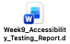

Axe DevTools screenshot showing zero violations
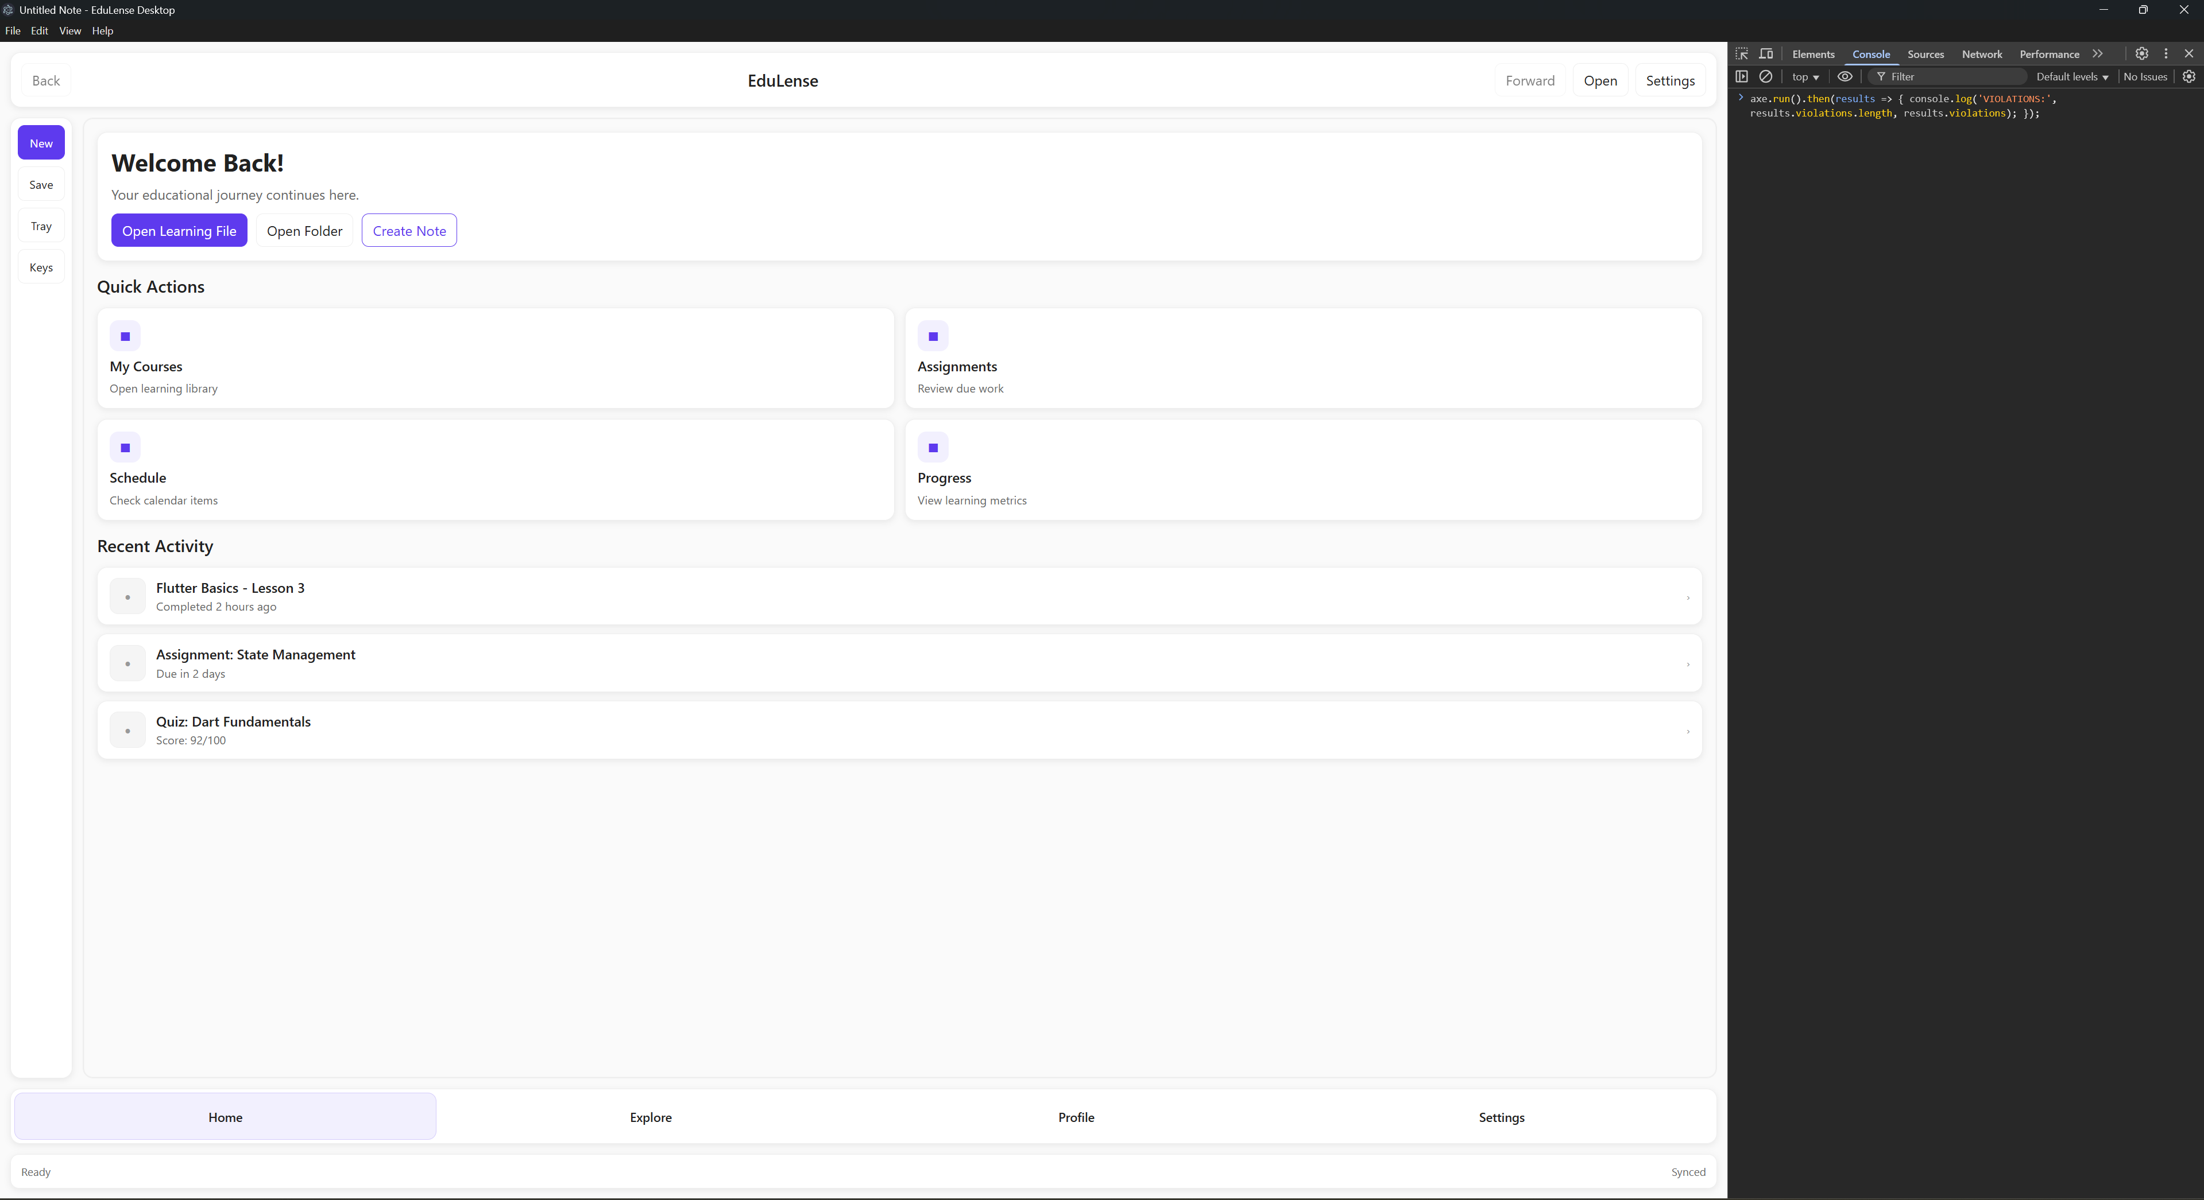

Keyboard navigation verification
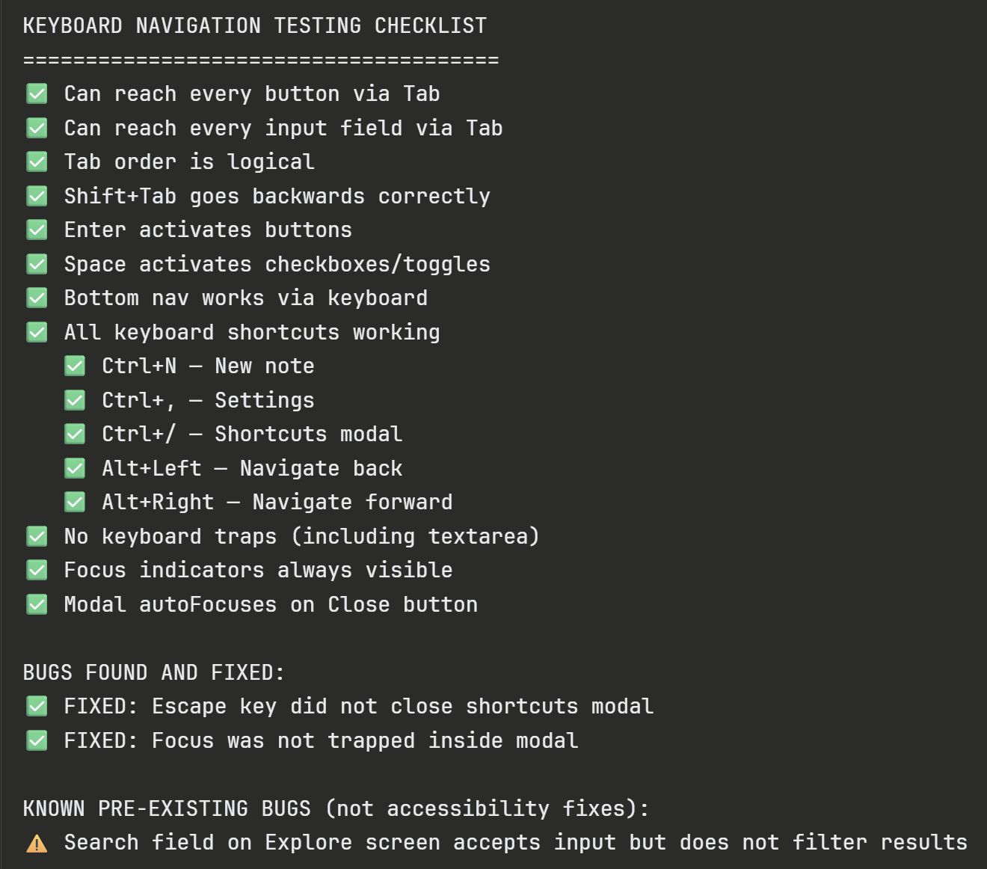
Video demonstrating complete screen reader navigation (5 min)

Desktop VPAT document (PDF or Word

Testing checklist (completed) = Kwame

Updated coverage report

10-15 minutes long video showing:

  - building and testing software from checkout out code from repository

  - your software meeting or not meeting required aspects and features
  - meeting or not meeting testing objectives and associated reports
documentation review

